**Healthy, Safe, Behaviours (HSB) Team**

**Service Description**

Birmingham’s Healthy, Safe, Behaviours (HSB) Team, is a specialist service for children and young people aged 7-17 living within the city of Birmingham, where there are concerns about harmful sexual behaviour. The team is now aligned with the Therapeutic and Emotional Support Service (TESS), with Lee Vince (Head of Service for TESS and HSB) and Lucia Malin as the HSB Team Manager providing the management structure.

The HSB team provide a range of services to children, young people, families and professionals with the aim of reducing risk and supporting young people to live happy and fulfilling lives. The HSB team accepts requests for support from the Early Help teams, Safeguarding, Children in Care and Youth Justice Services, where a social worker is allocated, and a family assessment is in the process of being, or has been, completed.

**Key aims of the Healthy, Safe, Behaviours (HSB) team:**

* Children are protected from harm and are safe at home with their families.
* Children have good emotional health and well-being.
* Children are better able to manage and understand the impact of their behaviour on themselves and others.
* Children and families have improved social and support networks.
* Children and families develop and sustain positive relationships.
* Children, and families are able to make positive choices about their lives and health and wellbeing and protect themselves from risky situations.
* Resilient families have improved stability, behavioural functioning and communication.

**Supporting young people and their families to understand and change harmful sexualised behaviour:**

Sexual behaviour in children and young people can be very concerning to the adults around. This can often be difficult for parents, carers, and teachers to respond to and can evoke strong reactions. An appropriate and consistent multi-agency response is key in managing sexual behaviour. Sometimes people may over-react to sexual behaviour and sometimes they may under-react or do nothing, neither is helpful. The HSB team provide support to parents, carers, and related professionals offering a supportive, educational, attachment and relational approach, responding to children and young people within a structured framework.

**What is harmful sexual behaviour?** Not all sexual behaviour in children and young people is problematic or harmful; some sexual behaviour is part of healthy development. It can sometimes be difficult to differentiate between developmentally appropriate, problematic and harmful sexual behaviour.

Harmful sexual behaviour refers to sexual activity that does not involve mutual consent by the individuals involved and/or where the relationship includes an imbalance of power, and where the behaviour has the potential to cause physical and/or emotional harm.

**Who is in the Team:**

HSB is a small and developing service who have recently moved under the TESS umbrella, with a view to develop a therapeutic service to meet the needs of children, young people and their families in Birmingham.

The team comprises of:

Head of Service for HSB and TESS

HSB Team Manager

Principal Clinical Psychologist (1 x Vacancy)

3 HSB Clinical Practitioners (3 x Vacancies)

2 HSB AIM Practitioners (inclusive of 1 neurodiverse focused practitioner)

1 Clinical Practitioner – 12M short term contract (1 x vacancy) (continuous review)

**Pre referral support: TESS Advice & Consultation Service:**

The team will aim to provide support, consultation and resources to those who are working with young people who engage in harmful sexual behaviour. The HSB team encourage consultations from any individual who is concerned about a child or young person’s sexual behaviour, including the young person themselves. The team also encourage professional consultations prior to submitting a request for support. This allows for discussions around safety planning, risk management and signposting.

When making a request for direct support to a child, young person and their families, there needs to be an allocated social worker or case co-ordinator with a completed family based assessment that has taken account of the presenting risk of sexual harmful behaviour. To support professionals in that process, referrers are advised to book into a HSB consultation.

Please note that all request for support will be offered a HSB consultation in the first instance. Consideration of any direct work/assessment will only be considered when it is felt there is a current imminent presenting need.

Any support provided by the HSB team is delivered as part of the child’s plan (Child in Need; Child Protection; or Child in Care plan).

**HSB therapeutic support for children, young people, and their parents and caregivers:**

The Healthy Safe Behaviours (HSB) team works with children who are exhibiting ‘problematic’, ‘abusive’ and ‘violent’ harmful sexual behaviours (Hackett continuum):

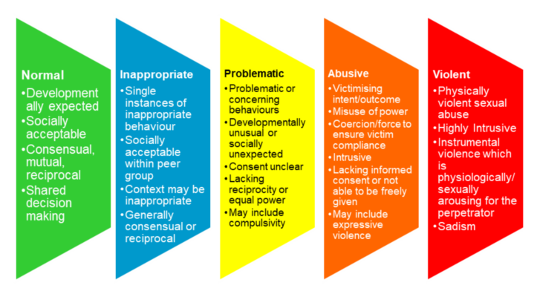

*Hackett, S. (2010) Children, young people and sexual violence. In Barter, C and Berridge, D (eds) Children behaving badly? Exploring peer violence between children and young people. London: Blackwell Wiley*

and level 4 ‘complex/ significant’ needs (Right Help Right Time):

[Right Help, Right Time - Birmingham Safeguarding Children Partnership](https://lscpbirmingham.org.uk/working-with-children/right-help-right-time)

Right Help, Right Time is designed to help you recognise what children and family’s needs are, and to take action with other practitioners and professionals to safeguard and provide support to them. It is important to offer help as early as possible to improve a family’s resilience and reduce the chances of their circumstances getting worse, as well as to recognise and act promptly when there is a risk of harm to a child.

Where suitable and appropriate to do so, the team offers a HSB assessment that explores the young persons presentation, emotional and relational experiences, and family dynamics, which may lead to a consultation and support, or more intensive intervention plan.

For those children and young people presenting with abusive and violent sexualised behaviour (*Hackett continuum*) an AIM3 approach would be adopted. This is a comprehensive process that helps us to work with young people, families and other professionals to understand the complexities of harmful sexual behaviour, develop appropriate interventions, and work towards a safer future for the young person and those around them. The AIM assessment considers various domains of a young person's life, including their sexual behaviour, non-sexual behaviour, developmental stage, environment, and family dynamics, identifying risks posed by the harmful sexual behaviour and the needs of the young person, including their underlying needs and potential protective factors. These assessments emphasize the importance of developing appropriate safety plans to protect both the young person and others from harm.

**Intervention plans** are based on an assessment and offers a direction of support designed to address the young person's needs and reduce the risk of future harm, which may include therapy, counselling, or other support services. The support offered also includes a focus on helping the young person move on to a safer and more positive future, which may involve addressing underlying trauma or other issues that may be contributing to the behaviour.

**Our links with local Mental Health Specialist Support:**

HSB is not a mental health, youth Justice, or safeguarding team, and do not provide crisis support service and therefore not in a position to offer diagnostic or specialist mental health assessments, support and urgent care. Where we support young people who may be experiencing higher mental health risk, such as self-harm and suicidal ideation, continued criminalised behaviour, and where the level of care sits outside of our HSB skill, knowledge, and expertise, we assist young people and their professional network to access more appropriate services, such as Birmingham’s local CAMHS service, Forward Thinking Birmingham, Birmingham Youth Justice Service, and Youth First (West Midlands Forensic CAMHS service), so that they can receive the care and support they require.